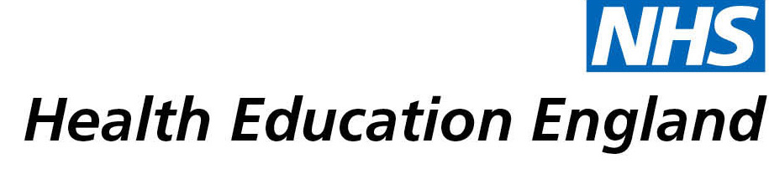

# Library and Knowledge Services case study

# Birmingham Community Healthcare NHS Foundation Trust Smallwood Library: KnowledgeShare bulletins

**Date: 23/08/2019**

## Reason for enquiry

The user contacted the Library to sign up to KnowledgeShare after making a series of literature search requests on topics in his field.

## What the knowledge and library specialist did

The Library service staff created an account for him and tailored his professional interests for him to receive bulletins with relevant evidence to his field.

# Impact of input from the library and knowledge service

The bulletins contribute to the level care that patients receive and form a source of evidence to improve on service delivery.

## Immediate Impact

Contributed to personal or professional development

“I think that it has had impact on predominantly personal/professional development and maintaining lifelong learning. It’s definitely contributed to the evidence base behind everything that I do and all of those things in turn lead to improvements in patient care both in terms of quality and in terms of safety because sometimes the things that are sent out are to do with safety and reducing waste or ineffective treatment so I think the impact is good”

Contributed to service development or delivery

“Sometimes there are multiple articles or links that are applicable so I would disseminate them throughout my wider team. Sometimes that will feed into some training. Sometimes it will just be for background information so in my field, I work in the Orthopaedic Triage Service, it’s really important that my clinicians remain up-to-date with developments within orthopaedics. So sometimes the articles are a development in the terms of a treatment technique or in terms of a protocol or in terms of a piece of equipment that is being developed or used or stuff like that. So I’ll disseminate the information through the team and then that would just sort of become part of day to day work. It may indirectly affect patient care because some of the knowledge that has been received and read will influence the decisions that we make regarding the management of the patient”

Facilitated collaborative working

Improved the quality of patient care

“The main thing is that it helps me and my team stay up to date and abreast of recent evidence and that’s very useful. So it contributes all day every day when we are seeing the patients. Sometimes it’s difficult to pinpoint one specific thing that it has contributed to because it sort of helps with just generally everything that we do.”

## Probable future Impact

Not supplied

## Submission by:

Damien Kimber, Orthopaedic Triage Service Clinical Lead, Birmingham Community Healthcare NHS Foundation Trust

## For further information on how you can get similar support contact your local NHS library and knowledge service.